CHAPTER IV

PROJECT TECHNICALITY

This chapter includes the system project scope wherein the purpose of the system focuses on the healthcare management of the healthcare. The use case diagrams are also discussed in this chapter by identifying the different flow of activities on the system. The usage case scenario involves the various tasks of the user inside the organization. The system prototype design of the system is also described in this chapter.

4.1 System Project Scope

This section discusses the SEMHMS. The project team decided to implement a web-based system that to perform every actual transaction with two users the desk in-charged and the doctor. The goal of this proposal is to help the organization integrate into the current operation and be able to develop an automated system to organize the records and generate statistical or comparative reports. The following are the specific target objectives of the project team in automating the current operation SEMHMS. Dental and X-Ray modules will be possibly included in future enhancements of the system.

4.1.1  Patient Profiling

The automated system is able to provide SEMHC an organized record for the patient. The project team objectives for automation is the records for several examinations conducted for patients and registration. The organization can easily access the particular record for the patient and can easily modify changes and updates in the patient record.

4.1.2 Scheduling

The system can provide a schedule for the patient registered in the system. The schedule may depend if the doctor requested the patient to take a laboratory examination or follow-up check-up. The organization can able to view the scheduled date for testing and monitoring check-up of the patients. The system can notify if the patient forgets to take the examination or follow-up check-up.

4.1.3 Health Progress Monitoring

The project team includes a health progress monitoring for the patient registered in the system. The organization may view the health progress of each patient and medical history.

4.1.4 Medicines and Medical Tools Inventory

The SEMHCMS system can monitor the inventory of the drugs and medical tools in the system. The automated can notify the organization if the stock of supply is small.

4.1.5 Generate Reports

The SEMHCMS system can print reports classified as, the number of the patient each month, health trend issue, patient result like the lab results, patient history and the inventory based on the data and information gathered in operation. Through date selection, the organization, as well as the proponents can interpret the comparisons between previous and latest data.

4.1.6 Networking

For the system to fully utilize its features, a local area network must be implemented to connect other departments. Having an efficient system network should allow the organization to maintain the network as well as connecting departments for data storage and retrieval.

4.2 Use Case Scenario

The Use Case Diagram shows how the actors interact with the system. It displays the step-by-step approach to complete the entire process. The desk officer can register a new patient or update the information if the patient has an existing account in the system, manage patient record which they can view patient information or make changes if necessary. The medical staff can also generate reports of how many patients has registered in the system by month or year, inventory reports of how many medicines are still available in their pharmacy, and laboratory reports that displays if how many patients undergo laboratory test in the organization.

The transaction starts when the patient is registered in the system where the medical staff gathers all their information of the patient to be stored in the system. Then, the doctor can view all the patients that are registered for consultation in the organization. The Doctor can also manage consultation schedule and patient record where they can update medical information of the patient in the system.

The pharmacist can administer the inventory in the system where they can view all the medicine details, add new medicine in the inventory, update or make changes to the medicines information in the inventory. The last actor is the medical technologist where they can manage laboratory records in the system. Figure 17 shows the use case diagram for the automated system.

Register Patient

Manage Patient Record

Medical Staff

Physician Manage Schedule

Manage Lab Records

Medical Tech Manage Inventory

Generate Reports

Pharmacist

Figure 17. Use Case Diagram of SEMHCMS

Table 20 shows the register patient function. The system allows the user to add or register the patient in the database. There conditions in this function when registering the patient. If the patient record exists, it prompts the user to update the record or not. If the patient record does not exist, then the system adds the patient record to the database.

|  |  |  |
| --- | --- | --- |
| Use Case Name | Register Patient | |
| Use Case Description | Medical staff register the patient in the system. | |
| Precondition | * Medical staff logs in with admin account. | |
| Post Condition | * Patient record is added. | |
| Activity Flow | | |
| Medical Staff | Interface | Database |
| Choose patient  management  choose  Add patient    User inputs  Patient record | No  Record exists?  Yes    Update? Yes  No | Add patient  record      Update patient  record |
| Alternate Flow | * Existing patient record updated. | |
| Exception Flow | * User cancels registering of patient, power interruption or error in network. | |

Table 20. Register Patient.

Table 21 shows the manage patient record. Once the medical staff chooses the manage patient record, it displays the list of patients registered in the system. The desk officer then has two options which to update or delete the patient record.

|  |  |  |
| --- | --- | --- |
| Use Case Name | Manage Patient Record | |
| Use Case Description | Medical staff chooses to manage patient record which functions include delete and update patient record. | |
| Precondition | * Medical staff or doctor logs in with admin account. | |
| Post Condition | * Patient record is either updated or deleted. | |
| Activity Flow | | |
| Medical staff/Doctor | Interface | Database |
| Choose  Patient  Management  Choose view  patients | Display list  Of patients    Update? Yes  No  No  View Yes | Patient List    Update patient  Data store  View patient  Data store |
| Alternate Flow | * Patient record is updated or viewed. | |
| Exception Flow | * User cancels adding of patient. Power interruption or error in network. | |

Table 21. Manage Patient Record.

Table 22 shows the management consultation schedule. This function allows the desk officer to manage the schedule the patients. The desk officer has two (2) choices; to update or delete the schedule of the patient. This should also allow the user to create a schedule for the patient.

|  |  |  |
| --- | --- | --- |
| Use Case Name | Manage consultation schedule | |
| Use Case Description | User manages the consultation schedule of the patient. | |
| Precondition | * Medical staff logs in with admin account. | |
| Post Condition | * Schedule is set. | |
| Activity Flow | | |
| Medical staff/Doctor | Interface | Database |
| User chooses  Schedule  User chooses view  patient schedule | Display  patient schedule  Exists? No  Yes  Update Yes  No  Delete? Yes  No | Schedule  information  Create  patient schedule  Update  patient schedule  Delete  patient schedule |
| Alternate Flow | * User updates or deletes the schedule. | |
| Exception Flow | * Power interruption, server or network is down. | |

Table 22. Manage Consultation Schedule.

Table 23 shows the manage inventory function of the system. This function allows the user to store the amount of medicines in the system. With this feature, it allows the user to monitor medicines stored in the inventory.

|  |  |  |
| --- | --- | --- |
| Use Case Name | Manage Inventory | |
| Use Case Description | User manages the inventory information about the medicine. | |
| Precondition | * Medical staff logs in with admin account. | |
| Post Condition | * Inventory details are managed. | |
| Activity Flow | | |
| Medical staff/Doctor | Interface | Database |
| Choose inventory  management  Add Yes  medicine    No Input inventory  details      View Yes  Inventory    No | Display inventory form  Display list of  medicines    Yes  Update    No    Yes  Delete    No | Store inventory  details  Inventory details    Update inventory  details  Delete inventory  details |
| Alternate Flow | * User updates or deletes the schedule. | |
| Exception Flow | * Power interruption, server or network is down. | |

Table 23. Manage Inventory.

Table 24 shows the manage laboratory records. This function allows the user to handle lab results in the system. The user then has two options which is to update or delete laboratory records. In managing records, it is important to keep track of changes that were made in modifying a record.

|  |  |  |
| --- | --- | --- |
| Use Case Name | Manage Laboratory Record | |
| Use Case Description | User manages the consultation schedule of the patient. | |
| Precondition | * Medical staff logs in with admin account. | |
| Post Condition | * Lab results are added. | |
| Activity Flow | | |
| Medical staff/Doctor | Interface | Database |
| Choose laboratory  management  Choose add new  Laboratory record    Choose  Lab request record    Add fecalysis  details  Add hematology  details  Add blood  chemistry details  Add urninalysis  details | Display list of  Lab requests | Consultation  datastore    Fecalysis datastore  Hematology  datastore    Blood Chemistry  datastore    Urinalysis  datastore |
| Alternate Flow | * Fecalysis, hematology, blood chemistry or urinalysis details are added | |
| Exception Flow | * Power interruption, server or network is down | |

Table 24. Manage Laboratory Records.

Table 25 shows the generate reports function. The desk officer has all of the records of the patient and is stored in a storage device. Upon the request of the Mother Superior, the desk officer can simply generate reports depending on the requested report.

|  |  |  |
| --- | --- | --- |
| Use Case Name | Generate Reports | |
| Use Case Description | User can generate reports | |
| Precondition | * Medical staff logs in with admin account | |
| Post Condition | * Reports are generated depending on the selected type. | |
| Activity Flow | | |
| Medical staff/Doctor | Interface | Database |
| Choose  Generate Reports  Choose report type  And date range      Print Report | Display Report  Form            Patient    Inventory  Lab results    Yes Print? Generate reports  No | Patient datastore  Inventory datastore  Lab results datastore |
| Alternate Flow | * User updates or deletes the schedule | |
| Exception Flow | * Power interruption, server or network is down | |

Table 25. Generate Reports.

4.3 Major Software Functions

This section shows the structure of the automated system. The figure below illustrates how the operation of SEMHCMS is organized in each module. Each component of the diagram is decomposed into lower levels or in a more detailed structure based on the activities of the organization. The following primary software functions for SEMHCMS is shown below in Figure 18.

Figure 18. Decomposition Chart of SEMHCMS.

4.4 Performance Issue and Management of Technical Constraints

In this section, the project team discusses the expected issue upon the implementation of the automated system. In line with the system concern, the team identifies the performance issue. The goal of the project is to provide solutions to the following problem mentioned below.

4.4.1 Slow Data Loading

Since a considerable amount of information is expected to be stored, there is a possibility that the loading speed would be slow. The solution for this issue is to have the organization acquire a high-specification computer, especially with the processor.

4.4.2 Data Storage

Since the organization has many patients every day, there is a possibility that the storage would become full. The solution for the organization is to have a high-capacity storage device as well as backup storage devices in case the hard disk drive would fail.

4.4.3 Generating of accurate reports

Since there, are many data stored in the system, the possibility of bugs existing in the system can cause inaccuracy when it comes to the generation of reports. The solution is to have the implemented system maintained for a period.

4.5 System Interface Description

During the design phase, the team started to conceptualize the physical design to cater the software and screen layouts. The concept is to manage all of the data in the data dictionary. The group didn’t have any problems in creating the interface because of new technologies like the bootstrap. This technology allowed the team to create a dynamic interface which the user can easily use and navigate. The interface is designed to be adaptable to the users in the organization with features that is popular to users.

Figure 19 shows the login page of the application. The user is required to enter login credentials. Having this feature in the system, it secure all the data that is being handled by the medical staff.

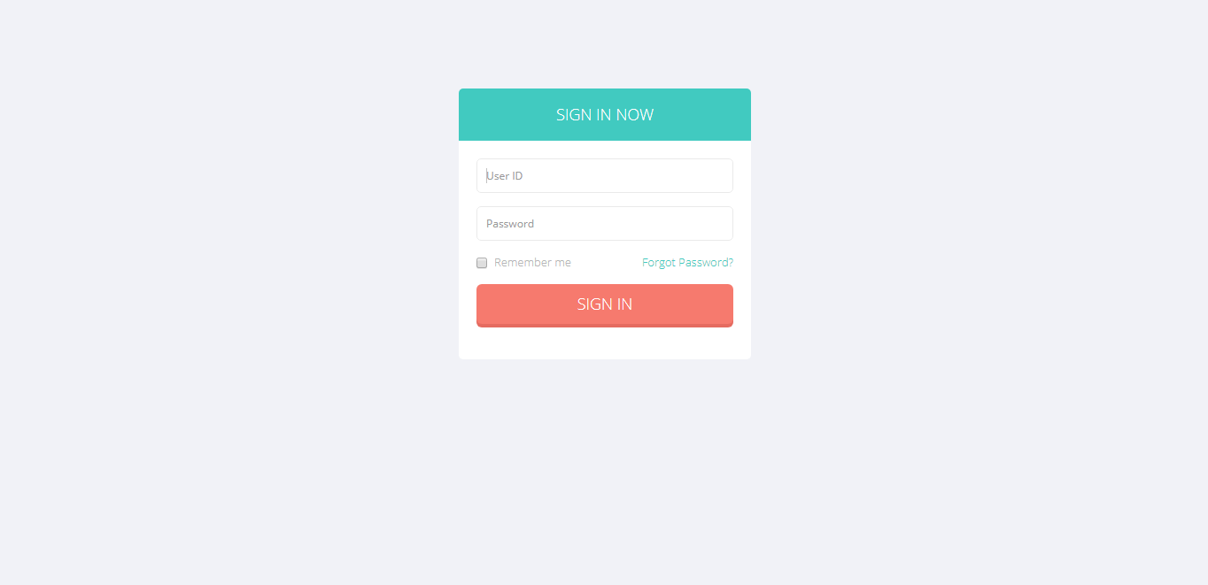

Figure 19. Login.

Figure 20 shows the home page of the application. The home page contains the patient management, schedule management, inventory management, users management, reports and maintenance functions. This is only accessible to the authorized personnel in the organization.

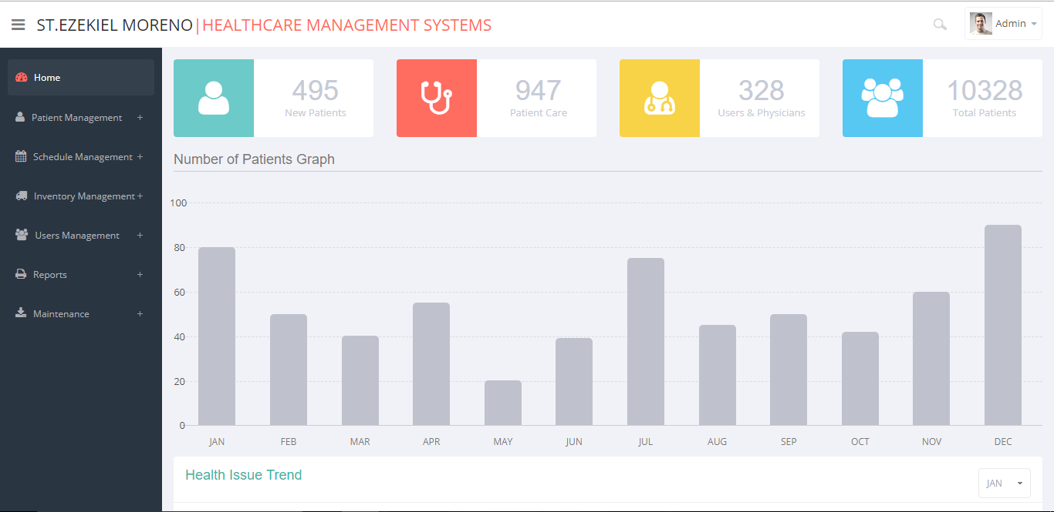

Figure 20. Home Interface.

Figure 21 shows the add patient in the patient management function. This is where the user can add a patient’s personal information. The system can capture the image of the patient for verification purposes. It involves patient ID, date registered and basic personal information. After adding the patient in the system, the information can be viewed in the view patient in the patient management function.

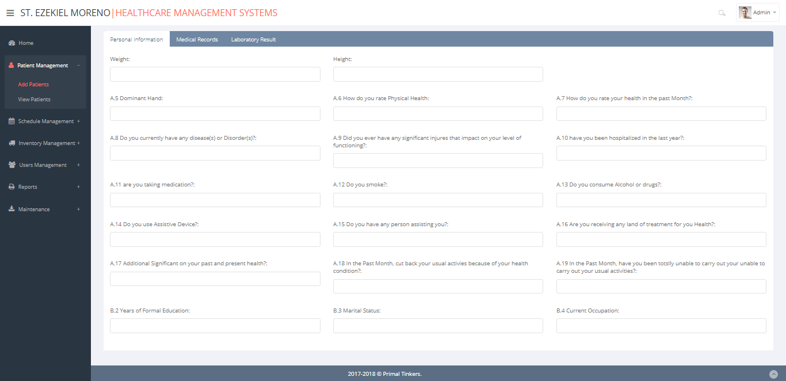 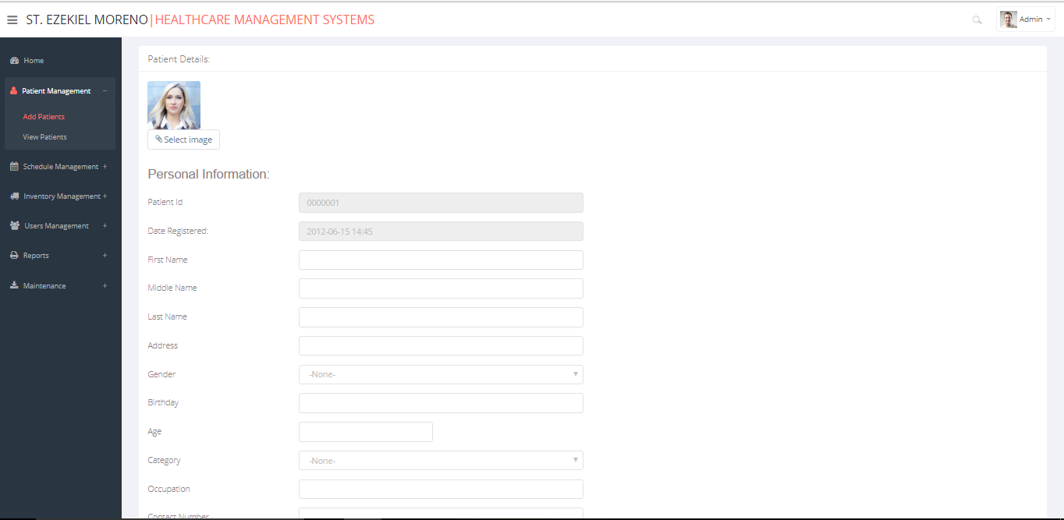

Figure 21. Add Patient Interface.

Figure 22 shows the view patient in the patient management function. It allows the doctor or the desk officer to view or update patient information. The patient is sorted depending on the user whether it be by patient number, name, health issue or status.

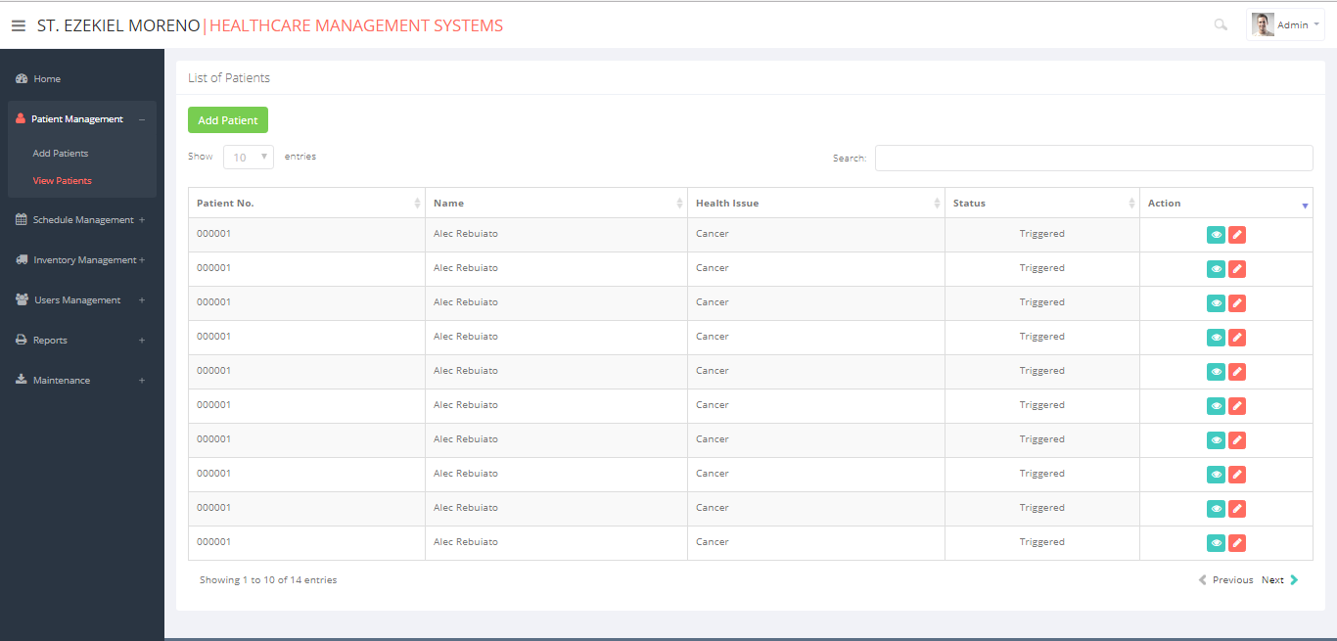

Figure 22. View Patient Interface.

Figure 23 shows the schedule management function with both set schedule and view schedule. In the set schedule, it displays a list of patients that can be scheduled. Information can be sorted by patient ID, name, health issue and status.

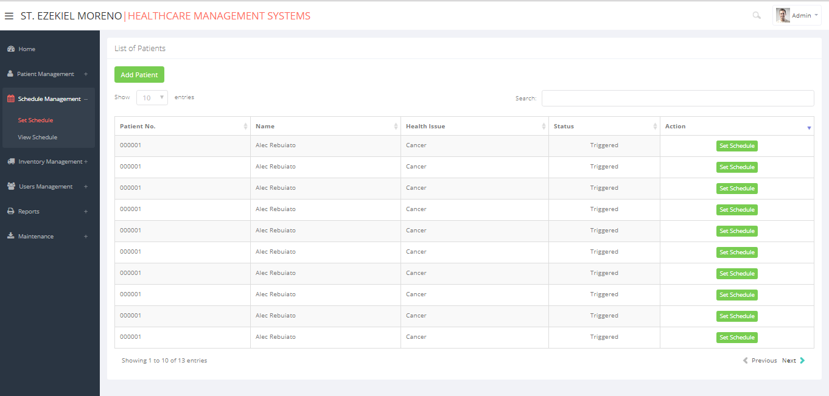

Figure 23. Set Schedule Interface.

Figure 24 shows the view schedule module in the schedule management function. It shows the patient list with a schedule set depending on the doctor’s advice. The schedule can be deleted if it is requested by the patient. The status of the schedule of the patient can also be changed if the patient’s schedule is either complete, ongoing, or pending.

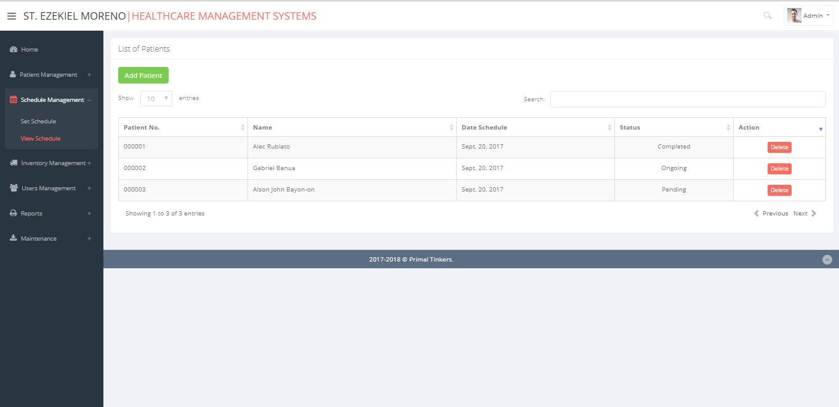

Figure 24. View Schedule Interface.

Figure 25 shows the add medicines in the inventory management function. It includes date arrived, name of medicines, quantity, supplier and remarks. This feature allows the user to add specific medicines in the database so it can be easily monitored by the pharmacist.



Figure 25. Add Medicine Interface.

Figure 26 shows the view inventory in the inventory management function. It shows a list of medicines available in the inventory with the status. The list can be either updated or deleted. This interface can be seen by the pharmacist.

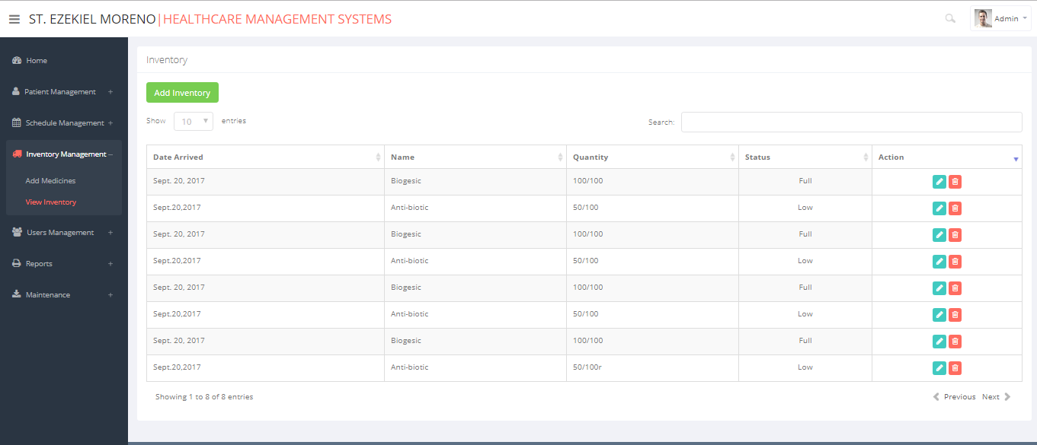

Figure 26. View Inventory Interface.

Figure 27 shows the add new user interface in the user management function. It contains the username, password, first name, middle name, last name gender and position. This function allows the user to add more users to the system if the organization has changes in the staffing.

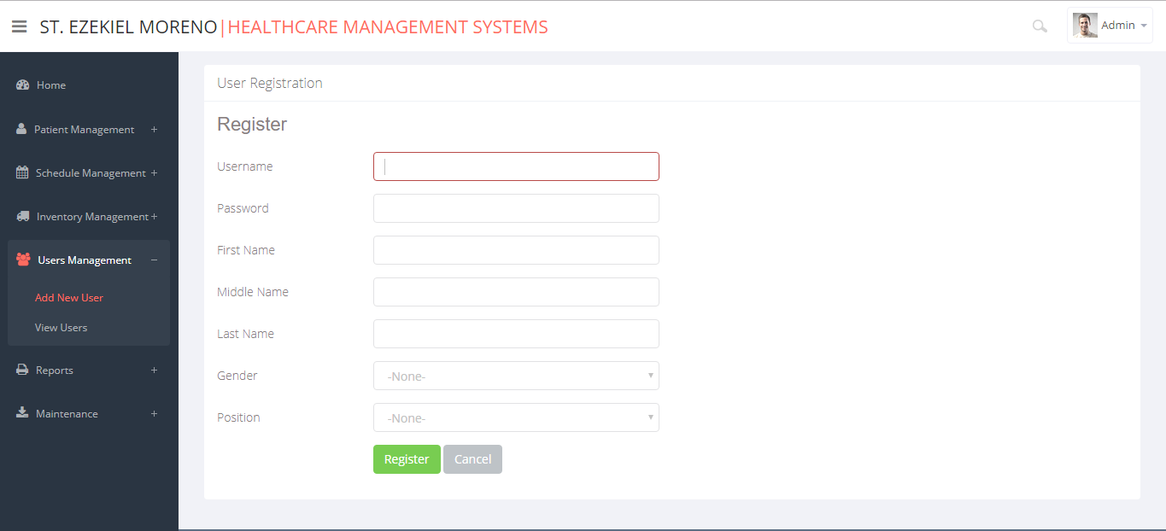

Figure 27. Add New User Interface.

Figure 28 shows the view users in the user’s management function. This function shows all of the users of the system. The user/s can be modified by the owner or the administrator. This also allows the medical staff to view who are registered in the system. This feature allows administrators to identify users who are logged into the network. The other purpose of this feature is for security purposes. User permissions can be verified before granting access to the system.

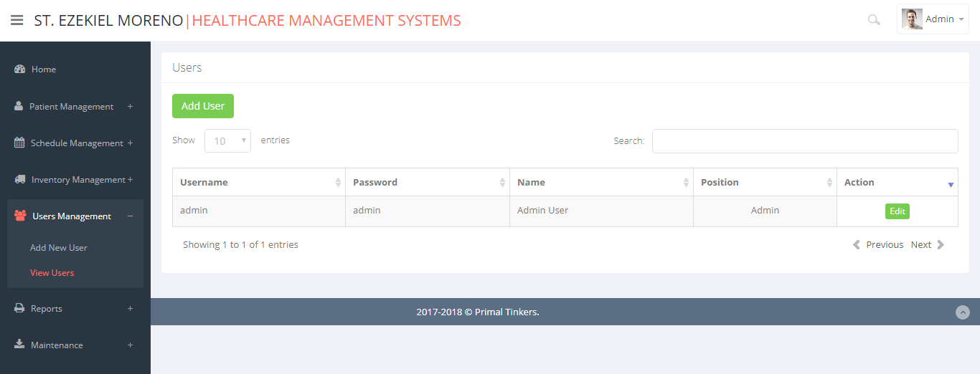

Figure 28. View Users Interface.

Figure 29 shows the reports interface. The user can choose a type of report needed to be generated as well as it can be sorted by date. All of the reports are basically gathered from the database. These reports include the patient, laboratory, or inventory.

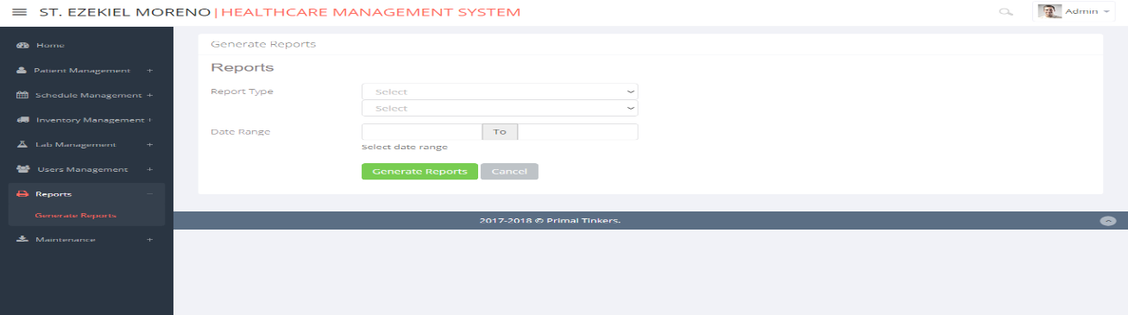

Figure 29. Reports Interface.

Figure 30 shows the backup module in the maintenance function. In this module, the user can save their data through backup database or transfer the database through the import database function. It is important to manage the patient information stored in the database.

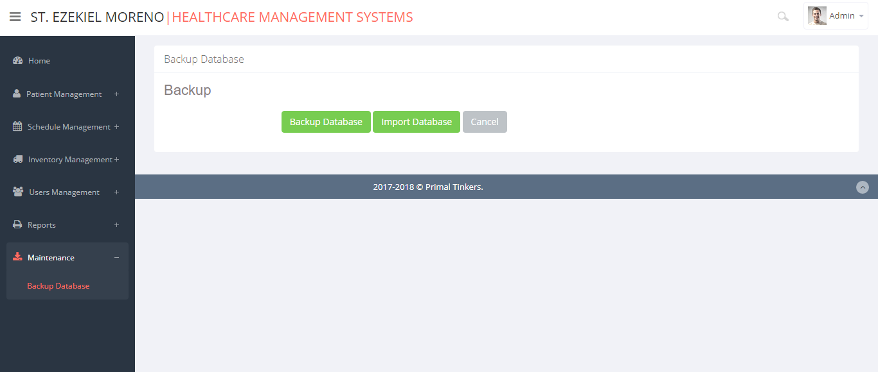

Figure 30. Maintenance Interface.

Figure 31 shows the Blood chemistry interface in the lab management. It lets the user input information regarding the blood chemistry results after the laboratory test. The blood chemistry includes fields like the personal information and examination fields which include international and conventional units.

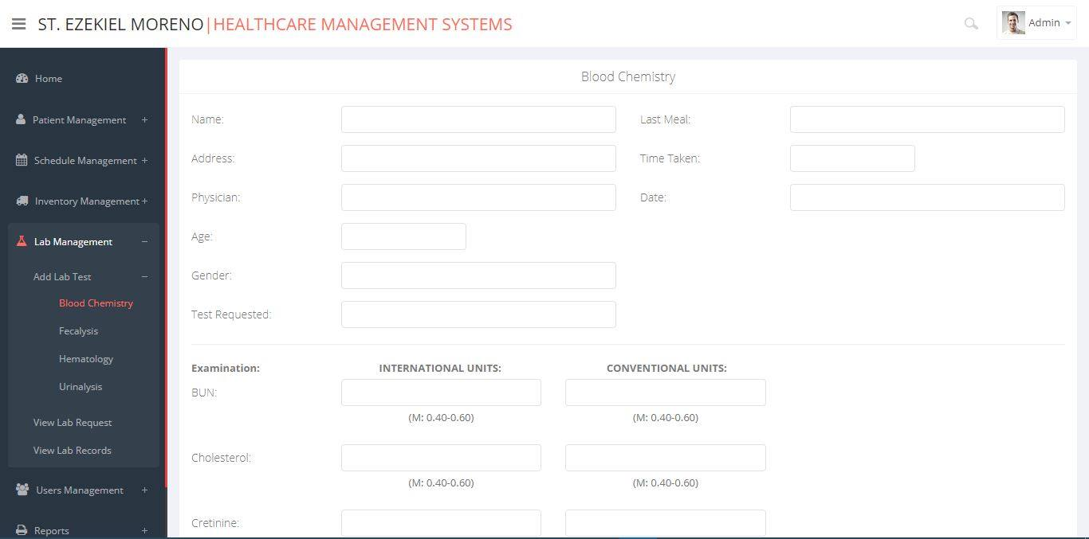

Figure 31. Blood Chemistry Interface.

Figure 32 shows the fecalysis interface in the lab management. It lets the user input information regarding the fecalysis results. This interface shows the user the fields that is based on the fecalysis form gathered by the team.

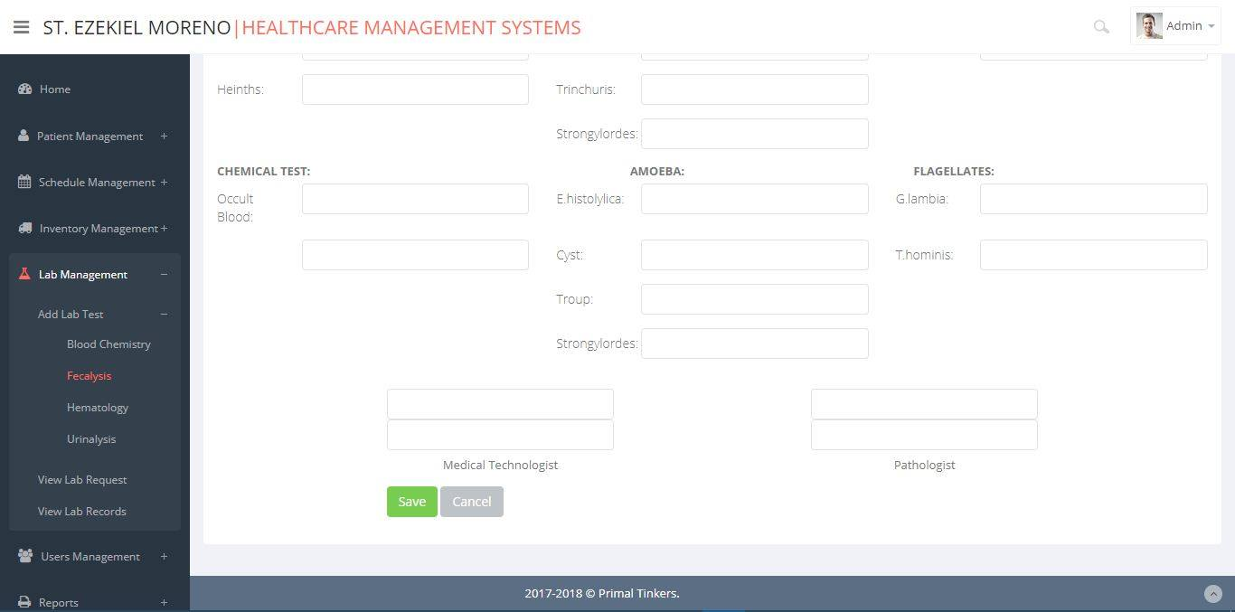

Figure 32. Fecalysis Interface.

Figure 33 shows the lab request interface in the lab management. It displays a list of patients that is in need of a lab request depending on the doctor’s findings during consultation. This interface can be seen by the doctor and the medical technologist. It also helps the organization operate faster when it comes to passing of data from the doctor to the medical technologist.

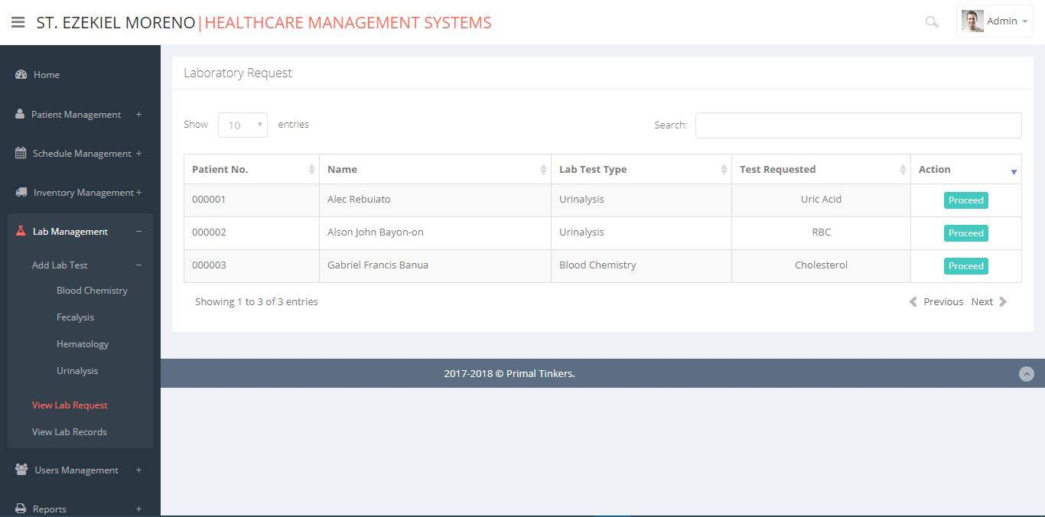

Figure 33. Lab Request Interface.

This chapter discusses the flow and the functions of the SEMHCMS. The project scope as well as the use case scenario were also discussed here. The group identified the goal of this proposal which is to help the organization integrate into the current operation and be able to develop an automated system to organize the records and generate statistical or comparative reports. Major software functions were also discussed to guide the group in developing the SEMHCMS. The performance issues and management of technical constraints shows the expected issues to be encountered as well as its solution. The use case diagram shows the overall flow of the SEMHCMS and the activity diagram shows the detailed flow of each use case. Basically, this chapter shows the overall purpose of the SEMHCMS as well as its flow of activities of the user and the system and sample screenshots are also presented.